Project Design Phase-II
Data Flow Diagram & User Stories

Date | 29 September 2026
Team ID | SWTID-2026-5660
Project Name | Script-Controlled ACL – Restrict Record Access Based on Field Value
Maximum Marks | 4 Marks

Data Flow Diagrams:
A Data Flow Diagram (DFD) is a traditional visual representation of the information flows within a system. A neat and clear DFD can depict the right amount of the system requirement graphically. It shows how data enters and leaves the system, what changes the information, and where data is stored.

Example: (Simplified)

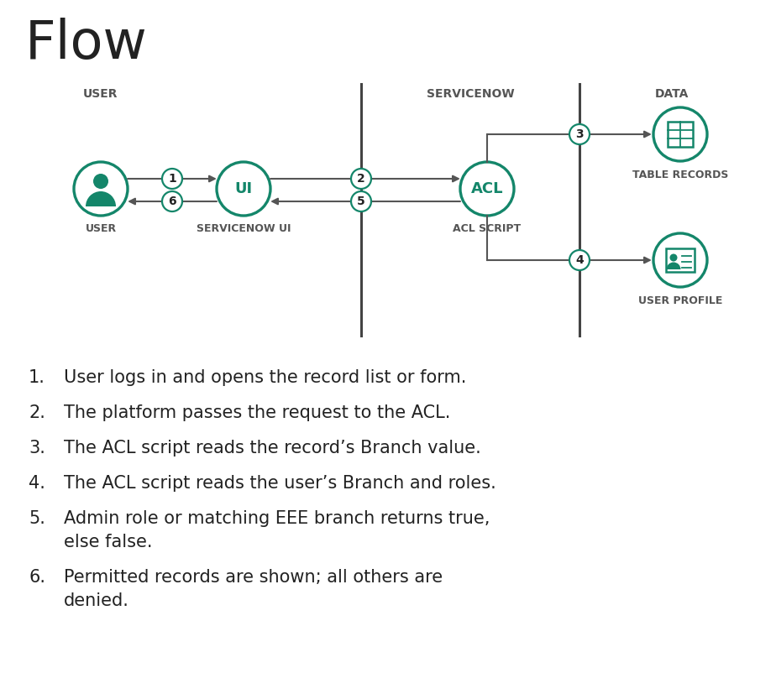

User Stories
Use the below template to list all the user stories for the product.
User Type | Functional Requirement (Epic) | User Story Number | User Story / Task | Acceptance criteria | Priority | Release
EEE Branch User | Login | USN-1 | As an EEE branch user, I can log in to the ServiceNow instance with my user name and password. | I can reach my home page and open the list of records | High | Sprint-1
 | Record Access | USN-2 | As an EEE branch user, I can view records whose Branch field is EEE in the list view. | EEE records are shown in the list | High | Sprint-1
 |  | USN-3 | As an EEE branch user, I can open an EEE record to read its details. | The record form opens without an access error | Medium | Sprint-1
Non-EEE Branch User | Login | USN-4 | As a non-EEE branch user, I can log in to the ServiceNow instance with my user name and password. | I can reach my home page | Medium | Sprint-1
 | Access Restriction | USN-5 | As a non-EEE branch user, I am blocked from viewing records whose Branch field is EEE. | EEE records do not appear in the list | High | Sprint-1
 |  | USN-6 | As a non-EEE branch user, I see an access-denied message if I open an EEE record link directly. | Record details are not displayed | Medium | Sprint-2
Tester | Testing | USN-7 | As a tester, I can impersonate an EEE user and confirm that EEE records are visible. | All EEE records are listed for the impersonated user | Medium | Sprint-2
 |  | USN-8 | As a tester, I can impersonate a non-EEE user and confirm that EEE records are hidden. | No EEE record is listed or opened | Medium | Sprint-2
Administrator | Data Setup | USN-9 | As an administrator, I can add a Branch field to the table and set the Branch value on users and records. | Branch values are saved and shown in the list | High | Sprint-1
 | Access Control | USN-10 | As an administrator, I can create a script-controlled ACL for the read operation on the table. | The ACL is active in the Access Control list | High | Sprint-1
 |  | USN-11 | As an administrator, I can write the ACL script to allow access only when the user is from the EEE branch or has the admin role. | The script returns true for EEE users and admins, and false for others | High | Sprint-1
 |  | USN-12 | As an administrator, I can view all records irrespective of the Branch value. | Admin sees EEE and non-EEE records | High | Sprint-2

Project Design Phase-II
Technology Stack (Architecture & Stack)

Date | 29 September 2026
Team ID | SWTID-2026-5660
Project Name | Script-Controlled ACL – Restrict Record Access Based on Field Value
Maximum Marks | 4 Marks

Technical Architecture:
The Deliverable shall include the architectural diagram as below and the information as per the table1 & table 2
Example: Order processing during pandemics for offline mode
Reference: https://developer.ibm.com/patterns/ai-powered-backend-system-for-order-processing-during-pandemics/

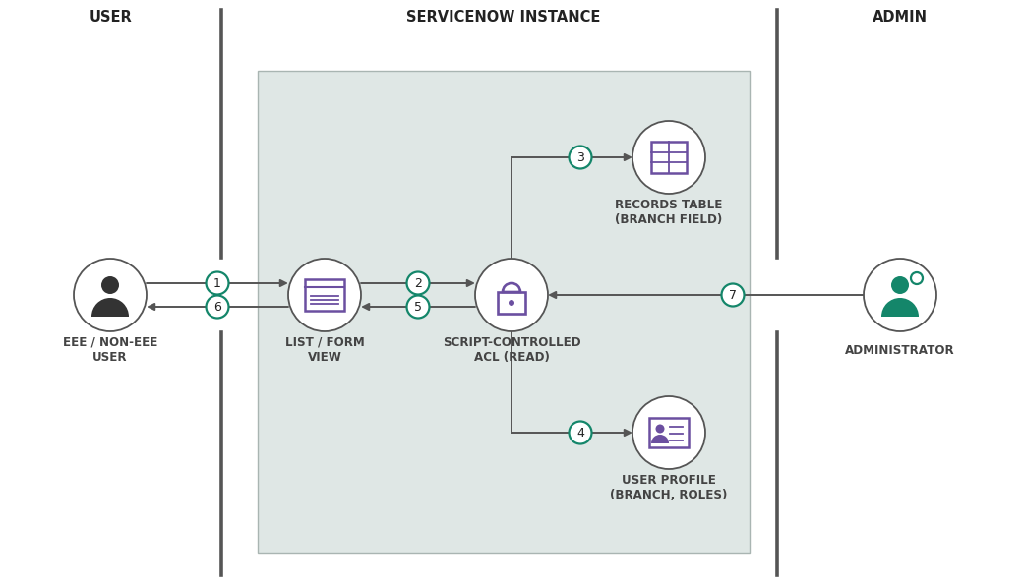

Table-1 : Components & Technologies:
S.No | Component | Description | Technology
 | User Interface | Users open list and form views of the record table in the ServiceNow web UI | ServiceNow Web UI (HTML, CSS, JavaScript)
 | Application Logic-1 | Script-controlled read ACL that allows a record only when the user’s Branch matches the record’s Branch (EEE) | ServiceNow ACL (advanced script), server-side JavaScript
 | Application Logic-2 | Administrator bypass: users with the admin role keep full access to every record | GlideSystem role check, server-side JavaScript
 | Application Logic-3 | Reads the record’s Branch value and the logged-in user’s Branch from the user profile | GlideRecord and GlideSystem APIs
 | Database | Record table with a Branch field (for example EEE) and the user table holding each user’s Branch | ServiceNow platform database (record table, user table)
 | Cloud Database | Database service hosted on the cloud by the ServiceNow instance | ServiceNow Cloud
 | File Storage | No separate file storage required; configuration is stored on the instance | ServiceNow instance storage
 | External API-1 | Not used; all data and logic stay inside the ServiceNow instance | Not applicable
 | External API-2 | Not used | Not applicable
 | Machine Learning Model | Not used | Not applicable
 | Infrastructure (Server / Cloud) | Application deployment on Cloud  Local Server Configuration: Not required (browser access only)  Cloud Server Configuration: ServiceNow instance (cloud-hosted) | ServiceNow Cloud

Table-2: Application Characteristics:
S.No | Characteristics | Description | Technology
 | Open-Source Frameworks | No external open-source framework; the solution uses ServiceNow’s built-in platform features and JavaScript | JavaScript (Glide APIs)
 | Security Implementations | Role-based access control with a script-controlled ACL on read, evaluated on the server, with an admin-role bypass | ServiceNow ACL, roles, user authentication
 | Scalable Architecture | Multi-tier ServiceNow platform; the same ACL script covers any number of records and users, and other branches need only a changed condition | ServiceNow multi-tier platform architecture
 | Availability | Hosted on the ServiceNow cloud, and the ACL is enforced on every request while the instance is available | ServiceNow Cloud
 | Performance | Lightweight script (one Branch comparison and one role check) evaluated server-side, so list and form load times are not noticeably affected | Server-side JavaScript (Glide APIs)

References:
https://c4model.com/
https://developer.ibm.com/patterns/online-order-processing-system-during-pandemic/
https://www.ibm.com/cloud/architecture
https://aws.amazon.com/architecture
https://medium.com/the-internal-startup/how-to-draw-useful-technical-architecture-diagrams-2d20c9fda90d

Project Design Phase-II
Solution Requirements (Functional & Non-functional)

Date | 29 September 2026
Team ID | SWTID-2026-5660
Project Name | Script-Controlled ACL – Restrict Record Access Based on Field Value
Maximum Marks | 4 Marks

Functional Requirements:
Following are the functional requirements of the proposed solution.
FR No. | Functional Requirement (Epic) | Sub Requirement (Story / Sub-Task)
FR-1 | User Authentication | Login with ServiceNow user name and password  Identification of the user’s role (administrator or regular user)
FR-2 | Branch Data Setup | Branch field on the record table (for example EEE)  Branch value maintained on the user profile
FR-3 | Script-Controlled ACL | Read ACL created on the record table  Advanced script comparing the record’s Branch value with the user’s Branch  Access granted only when the Branch is EEE for both
FR-4 | Administrator Access | Administrator role bypasses the Branch check  Full access to records of every Branch
FR-5 | Access Restriction | EEE records hidden from non-EEE users in list views  Access-denied message when a non-EEE user opens an EEE record directly
FR-6 | Testing and Verification | Impersonation of EEE, non-EEE and administrator users  Verification of list and form results for each user

Non-functional Requirements:
Following are the non-functional requirements of the proposed solution.
FR No. | Non-Functional Requirement | Description
NFR-1 | Usability | Users see only the records they are permitted to access, with no extra steps; a clear access-denied message is shown when access is refused.
NFR-2 | Security | Records with Branch = EEE are readable only by EEE-branch users and administrators; the ACL is evaluated on the server, so it cannot be bypassed from the client.
NFR-3 | Reliability | The script gives the same allow or deny result every time for the same user and record, handles empty Branch values safely, and never locks out administrators.
NFR-4 | Performance | The script is lightweight (one Branch comparison and one role check), so list and form load times are not noticeably affected.
NFR-5 | Availability | The platform evaluates the ACL on every request, so the restriction is enforced whenever the instance is available.
NFR-6 | Scalability | Works for any number of records and users; other branches can be supported by changing the Branch condition in the script instead of creating new ACLs.

